MYP4 Sciences – Criterion A Formative Assessment (Units 1–5)
(90 minutes, printed version)
Name: _____________________________
Class: _________
Date: ________________

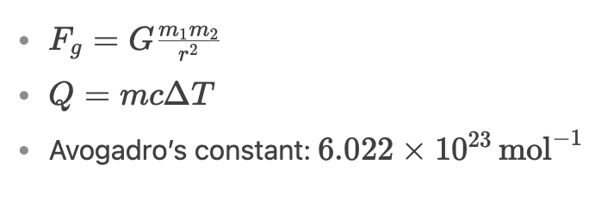
- Radius of Earth = 6’371 km

Section A: Knowledge and Understanding
- State the SI unit for mass and the prefix for 10⁻⁶. [1-2]

- Order from largest to smallest: Hydrogen atom, Mitochondrion, Carbon nucleus, Glucose molecule, Human egg cell. [3-4]

- Describe the purpose of a control group in an experiment. [3-4]

- A student measures a cell image with a 5 µm scale bar. Calculate the cell’s actual size (entire red segment). [5-6]
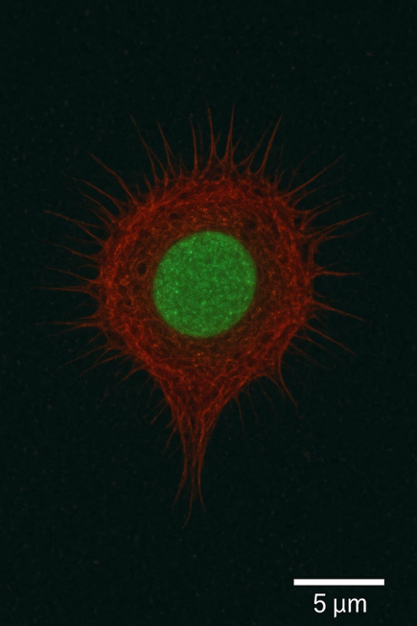

- A scientist claims, "One experiment is enough to prove a theory." Evaluate this statement. [7-8]

- Draw an atom and its subatomic particles [3-4]

Section B: Application and Analysis

- Identify the subatomic particle(s) that:
a) Differ in isotopes. [1-2]
b) Are lost to form a Ca2+Ca2+ ion. [1-2]
- An element has 20 protons, 20 neutrons, and 18 electrons.
a) State its atomic number. [1-2]
b) Explain why it’s charged. [3-4]

- Draw a labeled diagram of a carbon-12 and carbon-14 atom, highlighting their differences. [5-6]
Carbon-12 Carbon 14
- Calculate the gravitational force between Earth (5.97×10²⁴ kg) and a 500 kg satellite 200 km above its surface. [7-8]

- Compare ionic and covalent bonds in terms of electron behavior. [5-6]

- State three trends in the periodic table, and their direction.

- Analyze the trend in atomic radius across Period 3 (Na to Ar) on the periodic table. Explain how electron shielding and effective nuclear charge contribute to this trend. [7-8]

Section C: Evaluation and Synthesis
- Balance the equation:
Al + O2 → Al2​O3​ [3-4]

- Interpret the electronegativity trend across Period 3. [7-8]

- A 50 g sample of iron absorbs 450 J of heat, increasing its temperature by 10°C. Calculate its specific heat capacity. [5-6]

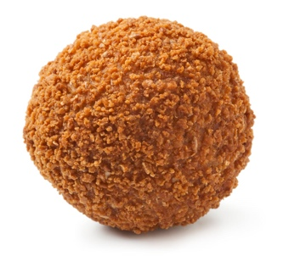

- Evaluate whether a cold “bitterbal” crust means the filling is also cool, given:
  - Crust c=300 J/kg/°C
  - Filling c=3500 J/kg/°C [7-8]

- Design a method to estimate the number of fish in the lake in the image using sampling. [7-8]

A student reacts 12.6 g of magnesium (Mg) with excess hydrochloric acid (HCl). The balanced equation is:
Mg + 2HCl → MgCl2 ​+ H2​
- Calculate the number of moles of Mg used.

